**INTERNSHIP REPORT**

**ECOGIF COMANY, OXFORD**

**Table of Contents**

Chapter 1: Introduction 4

Internship Purpose 4

Problem Statement 5

Job role 5

Objectives of the Internship 6

Chapter 2: Technical / Literature Review 6

Analysing the Software Development Methodologies 7

Practical Application of Python and Utilisation in Software Development 8

Practical Application of JAVA and Utilisation in Software Development 10

Chapter 3: Methods 12

Selected Method 12

Description of Method 13

Agile Software Development Method 13

Scrum Framework 15

Agile in Ecogif 15

Reasons for Choosing the Agile Method 16

Appropriateness of the Agile Method 18

The utilisation of programming language 18

Techniques 19

Chapter 4: Analysis / Results 20

Company Description 20

Settings of the Study 22

Presentation of Results 23

Findings 25

Chapter 5: Interpretation and Conclusion 26

Points from the Literature 26

Practical Application 27

Conclusion 27

Reference List 28

# Chapter 1: Introduction

Internships are referred to as the experience of working under an experienced employer who provides the opportunity for the students so they can get the proper exposure to the working industry in a particular domain they have selected. It helps us to grow in our professional careers by sharpening our professional skills. Generally, internships are based on a definite period of time and can be both paid along non-paid. The exposed personnel hire some talents that are fresh in the job sector and hire them as 'interns' for a specific duration of time so that they can acquire the state working culture. Only after joining the internship program at 'Ecogif" Company (Ecogif. co, 2023), the benefits that one can get in their professional life from one internship I acquired. In the company Ecogif, as a software developer I joined the internship to develop my passion and build my career stronger. As a software developer designated in the internship program the main, objective that I got to learn was that only performing coding and developing the software were not my key jobs. Apart from doing this, I had to maintain my communication and relationship skills with other teammates with grace and it is also my responsibility towards my company and work. In theory, I can get any kind of knowledge in my selected domain but to get real-world experience and problem-solving abilities this internship has played an effective role in my professional life. Besides having a reasonable relationship with the other team members, it is important to maintain a proper relationship with the clients is also important along with maintaining proper behaviour with everyone equally essential. In addition, I learned that there is more to internships than these, which is my professional network has grown within the time period of the internship meeting different people of different domains, which assists in developing a positive attitude, skills enhancement, and confidence. During the whole internship, I understood the value of being a software developer and how to apply that in my professional career.

## Internship Purpose

The significant reason why I applied and chose to perform the internship program with Ecogif company, in order to embrace along with to enhance the abilities and skills I have in software development with the help of Python and JAVA programming language. With the help of this opportunity, I wanted to increase my knowledge and develop problem-solving abilities so that I can be able to apply the tricks in the industry at the time of doing a full-time job. I have seen that with no prior experience in the domain, at the time of wrong, it develops challenges to survive in the organisational culture.

## Problem Statement

This has become a modern as well as much developed world nowadays by utilising the internet efficiency. The world is evolving with the help of the internet and the software products that have been created. Due to that, the demand for not only software products but also developers has increased by a high amount in the Information Technology (IT) industry. Thus most organisations have started to adopt the technologies and production at a rapid speed to meet the high demand of the market. The products that are being made nowadays are complex in terms of their manufacture. The organisation on the other hand are focusing on the quality of the products so that they can meet the customer's wants. Whereas along with getting all the effectiveness and advantages there are various aspects that have created issues in the industry that can harm customer privacy factors. As a software, it is my responsibility towards my work to build software products that could attract more customers and it for customers it feel easy to use. As I am a software developer from my designation in the Ecogif Company, I have come to gather some essential information towards my role. It has been my knowledge that as the world is evolving at a rapid speed, there is a big role that is being played the software developers. Whatever problems I may face in the future times in the line of work I will be able to overcome them because of this internship. In this internship, there are various aspects that I have learnt that it is my responsibility to make the software that would be used by various customers out there. Software products have not only become the present but also the future. The learnings that I have learned during this internship have made me enough confident to work in the future without making huge mistakes.

## Job role

The job role that I had in the company Ecogif (Ecogif | LinkedIn) for the internship, was a ***Software Developer.*** My responsibilities are to develop any kind of software product per the customer or client requirements with any of two programming languages Python or JAVA. As everything is digitized, people are becoming dependent on software products now more than ever. Thus sometimes I feel good as I have chosen a domain where there is a future and it can open multiple paths for me there. In my roles in the company I had to perform multiple jobs related to software development such as designing the software and implementing the product by applying different programming languages, in addition, managing those software products after the implementation also came under my role. In order to perform all the activities, proper research is needed. Following that, if there is any kind of chance order to improve the functionality of a product that already has been developed is tested for modification. Furthermore, in order to develop new programs, testing and evaluation are performed. Proper coding is the fundamental factor of this role. Only the proper and efficient coding would be able to make a product work in a way that every user out there can use it to the fullest. Being a developer, it is I have to keep in mind that at the time of doing the project, the coding should be proper. The product has to be responsive, which means on the computer, phone or iPad, the product would look with proper design and style. In recent times, the Python language has been popular amongst developers because of its diverse advantages such as extensive libraries that are predefined, less writing code etc. On the other hand, it is JAVA that also carries multiple advantages that can make a product look and work better.

## Objectives of the Internship

The fundamental objective of this internship has been illustrated beneath

* To analyse the software development methodologies
* To understand the role Agile method in the Software Development field
* To analyse the practical application of Python Programming Language in order to build any kind of software application
* To analyse the practical application of the JAVA Programming Language in order to build any kind of software application

In order to complete my internship at the manufacturing company *Ecogif* I joined as a *software developer intern* (Kumar *et al.,* 2019). Here the responsibilities I had were to build profound, user-friendly and sustainable software for the company. Developing the software applications as per clients' requirements was the primary responsibility of the internship. In this regard, the company have allowed me multiple times to show my creativity and technical skills in the tasks to make them work in a proper way. Along with my technical expertise, I used my decision-making and problem-solving skills in the internship to give my best in the work that I have been doing. In this context, it has been seen that for better communication and to make the tasks along with the team more productive and sustainable, the method Agile has been chosen by the company along with the other factors. For the development of software products, the two most famous and scalable programming languages have been used in this internship. The two languages are Python and Java. Combining these two with the agile methodology has made my products satisfactory.

# Chapter 2: Technical / Literature Review

From the very scratch in order to develop one software application there are various parts that need to be implemented first. Software development is nothing but dividing the whole development process into smaller parts or sequential parts so that developing the application gets easier for the developer. Dividing into separate parts of software development is known as the software development life cycle (SDLC). In general, in one software development life cycle, there are 6 steps to follow. In order to develop software in a proper and accurate way as per the requirements every developer follows these 6 steps describe as, to begin with, the first step is *planning* the processes of building the software, in addition to the second step is the *analysis of* the planning makes the tasks accurate, then the next step is *designing* the planned and analysed process, as the fourth state the *implementation* process occurs where the codings are written by the developer with the help of different efficient programming languages. In the next step testing and integration are done after properly writing the whole code based on requirements and lastly, after completion of developing the software product *maintenance* comes in. In case any modification is needed in the software product the maintenance part is executed. In this internship for developing software products the programming languages that I have used are Python and Java which will be discussed below.

## Analysing the Software Development Methodologies

As per (Mohino *et al.,* 2019), a framework that represents the operations adopted by organisations in order to create any software application from the very scratch to the end till it is ready to deliver to the client is known as a software development life cycle or SDLC. The whole procedure is known as the life cycle. In this research paper, the authors have mentioned various methodologies in software development. Along with this have described the steps of a software development life cycle as a first step it is important to identify the requirements that are given by the client following those requirements designing the architecture is needed, and in addition to that architecture coding is written, then after finishing the codification process testing begins and following the testing, if any modification is required in the application then maintenance is done in that software application. English research papers suggested using agile methodology in the tasks. The authors (Mohino *et al.,* 2019) have emphasized the fact that agile methodology follows the philosophy of collaborating with the team members and sharing the work which not only helps in finishing the work faster but also increases the productivity among the team members. Using other methodologies in the organisation by increasing the product ability and making the software application more efficient reaches customer satisfaction. As per the authors, four sister methodologies should be followed first is over tools and techniques focusing on individuals and communication is more important, then the second is working on the software application over focusing mainly on the documentation 3rd collaborating with the clients and negotiating over any contract is vital for the project and lastly if any changes appear then responding to that by maintaining a plan is elementary.

According to (Saeed *et al.,* 2019), through deep analysis, they have focused on various methodologies that make any software application more efficient and which methodology is the best one to develop any software product in its most efficient way. In order to develop any software the authors have stated that there are various factors on which it depends, for example, on the type of the project, the size of the development environment, and the resources that are available. Various different methodologies have been discussed by the authors (Saeed *et al.,* 2019) in this search paper along with their strengths and weaknesses in software development. Authors have done a comparative study on the different methodologies that have a direct effect on software development life cycles. Come to the conclusion that two fundamental types of philosophies are there in the software development domain. As per the authors, one of the philosophies is light and the other one is heavyweight. It has been analysed by the authors that the projects in which there are no changes required along with there are proper complexity are present, as per the client's requirements the philosophy heavyweight is applicable. Along with this, it has been observed by the authors that this methodology is easier in order to implement in the software application. Also, the process of understanding is better in this methodology as the documentation is clear. In this methodology, each teammate has proper freedom by working on the requirements without any interaction whereas the project owners only participate at the time of performing the research action and planning. On the other hand, the light methods are applied in the project where there are chances of changing the requirements in the middle of the development. With the help of this methodology, the developers can make changes as per the requirements of implementation. In the end, it has been concluded by the authors that iteration-based models are one of the best in order to develop a software application.

## Practical Application of Python and Utilisation in Software Development

According to (Thaker and Shukla, 2020) the authors it has been illustrated that in recent times, python has become one of the most popular programming languages among numerous developers across the world. The authors have stated that it has been at the top of the programming languages for over five years now.

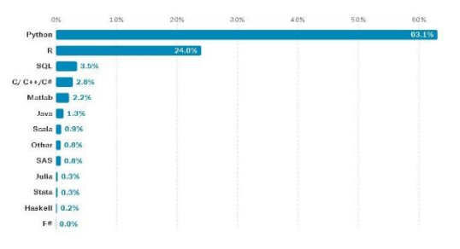

Fig: Popularity of Python

Source: (Thaker and Shukla, 2020)

In the above image, it has been seen that among numerous different programming languages, Python has the most popularity in the recent market. Compared to other languages, the results of popularity, Python is at the top with 63.1%. The authors have stated that this language is an open-source language that was first created by Guido van Rossum. In the research paper, the authors have mentioned multiple characteristics of Python that make the programming language more versatile among developers. Apart from various advantages Python provides, there are such databases that are supported through Pyhton for example it can be said that Python is extensible and scalable and thus, it supports databases such as MySQL, SQLite, Google Cloud SQL, PostgreSQL, no SQL MongoDB, Amazon Relational Database Service(RDS) etc. In the case of developing or building any software application, it has been seen that Python has played a major role in proper accuracy. Being a scalable language python has a versatile nature in the domain of software development. There are many protocols that are used in order to build the software application. It provides various internet protocols for developing any application such protocols are HTML, XML etc. Various frameworks are provided by Python to make the application more efficient such as Django, CherryPy, etc.

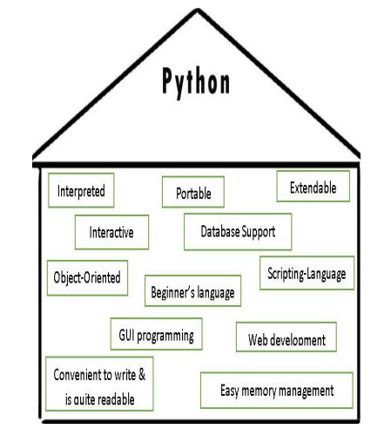

Fig: Features of Python Programming Language

Source: (Thaker and Shukla, 2020)

Here from the above image, can be seen that it illustrates various features of the Python programming language. Such as, it is portable, supports database, interpreted, scripting language, GUI programming etc. and many more advantages are there which have made this language popular. Apart from software development, there are various roles and applications out there that are done by Python which are, in the field of data science, IoT in the field of Artificial Intelligence, and Machine Learning and Deep Learning. The paper shows the Python programming language as multiple paradigms. The authors (Thaker and Shukla, 2020) have concluded that in the meantime it is the most flexible programming language in the market having versatile applications.

## Practical Application of JAVA and Utilisation in Software Development

In the research papers according to (Khoirom *et al.,* 2020) comparative analysis of the Java programming language has been performed. For the first time, James Gosling was the one who introduced the world to this programming language. The advantage which is why most organisations have adopted this programming language is its WORA (Write Once, Run Anywhere) nature. Despite the operating system or run time environment, after writing the code once that code is runnable anywhere. This is why JAVA is considered a platform-independent programming language. Java is considered to be a typed language as the variables in this language need to be declared prior to assigning the values. As per the authors (Khoirom *et al.,* 2020), it has been stated by performing a comparison between Python and Java on their run time speed and it has been found that Java has adequate speed than Python language.

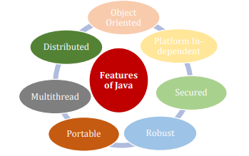

Fig: Feature of Java

Source: (Khoirom *et al.,* 2020)

In the image above the various features of Java have been shown. Various features of Java are such as Java is an object-oriented programming (OOP) language that assists in addressing real-world issues. Apart from that it already has been discussed that Java is a platform independent platform. Besides, as Java uses JVM it is considered far more secure than the other programming languages. The programming languages have better storage and the things that are not needed in the coding have the ability to get rid of automatically because of all the exception-handling techniques, Java is considered to be robust. Following that as Java is a platform-independent programming language the white codes of Java are transferable to any platform without needing any help of implementation thus the programming is portable. It has always been considered that Java is an application that is highly interactive and has responsive applications for doing multiple tasks at one time also as it has a common memory storage it is known as multithreaded which makes it perform more satisfactorily than others. As features, it can be said that Java is a distributed language as from any computer files can be accessed.

There is a huge role that is played by Java in the software development domain. In order to develop any kind of Android mobile application Java is considered to be the best programming language in this regard. According to (Khoirom *et al.,* 2020) authors, it has been articulated that there is a virtual machine for Android that is named Dalvik Virtual Machine (DVM), and in this specialised virtual machine, the byte code of the Java compiler runs. Most developers use Java in Android applications as the object-oriented programming principle provides adequate security along with a straightforward and effective user interface in Android applications. In order to bill software applications that are web-based Java plays a significant role there. In software applications that are web-based, Java uses its servlets, JSP (Java Server Pages) etc. As has been discussed by the authors previously also Java provides better security compared to others thus huge E-Commerce platforms, for example, Broadleaf are provided resources from Java programming language. Apart from using Java in Android applications and web-based applications to develop software products, in order to make desktop GUI applications in cloud-blessed applications and in big data technology this versatile flexible, scalable programming language is utilised.

As per (Khoirom *et al.,* 2020), the authors, it has been illustrated that Java has diverse adaptable applications and benefits not only in the field of software development but in other domains also. The advantages of Java are, that it is one of the easiest languages in order to write, compile the bug and run. Next is Java is platform independent; it supports multithreading, it is a distributed language and can handle exceptions in an automatic method, multiple developers acknowledge that Java is an endorsement in the software development industry. Another advantage of Java is that as it is object-oriented programming the codes are reusable so in multiple projects parts of coding can be reused. For software development database is an essential part and Java contains an inbuilt API that connects to the database in an easier way. Along with these advantages, Java contains an extended number of proven libraries together with frameworks that help in the procedure of software development.

# Chapter 3: Methods

## Selected Method

The method that has been selected in the internship program, which I have done in the company Ecogif, is as I will use software development methodology. Software development is a complex process as it contains multiple steps of coding for different parts of the software product. That is why it is important to take a soft methodology that is appropriate for this job rule. I have taken an agile methodology which is an iterative approach to developing any kind of software product.

Many software development methodologies are there in the market but among those agile methodology is considered to be one of the best and most effective. It is not only effective and best but also it has also gained most of the developer's popularity nowadays because of the flexible nature it has towards the development of the software product. From various research papers, it has been conducted and it has been gathered that most of the time almost 27% of the time, agile methodology (Perkusich *et al.,* 2020) has gained success in the project development field. Inazine methodology is followed in multiple steps which is why it gives better results and is more flexible. It is considered that agile software development methodology has better sustainability development factors than the others. For example, managing code in a proper way so that it does not get wasted or it does not get lengthy also the time of testing the product gets automated to test the quality of the product the methodology shows is a sustainability factor.

## Description of Method

### Agile Software Development Method

As I have described earlier also that today's world is changing at a rapid speed along with organisations. Businesses nowadays change their requirements as per customer demands and customer demands vary with time. Thus it has been the obvious reason for organisations to change the requirements based on clients' pieces of information. At the time of developing the project many times, the requirement changes of ships want to another, at that time random software development the benefits that come at the point of developing as it goes on in one cycle only. That is why those after-development methods fail to deliver the product as it fails to meet the requirements. This fast-forwarding industry is the reason for the birth of *Agile Software Development methodology* (Dudhat *et al.,* 2021). Requirement nowadays changes anytime any point in the moment that's why the agile methodology after each cycle, has the ability to change the requirement. As a reason for various uncertainties in the project work in the organisational sectors, the method was invented.

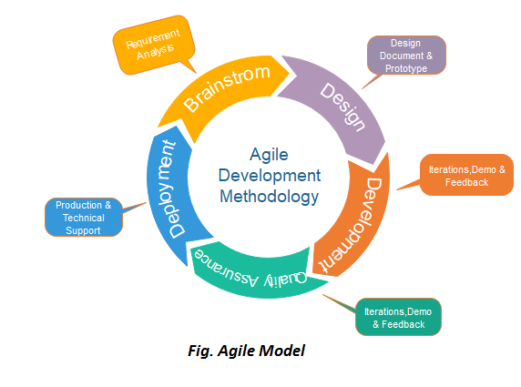

Fig: Agile Software Development Model

Source: (Dudhat *et al.,* 2021)

Apart from being a method for software development, Agile has its own philosophy approaches and values along with some set of principles that follow this method so that it can be able to deliver accurate products in the best way possible to the client as per the requirements. Among these, there are four main values and twelve principles that together work to deliver a better product to the client. As my role is a software developer I have to focus on the software life cycle that would focus on high-quality software. With the help of Agile methodology, as there are iterative processes in the life cycle of the software product the quality of the product gets better (Dudhat *et al.,* 2021). Some iterative phases in the software development life cycle are followed at the time of development. The iterative steps are the following

* *Requirement Gathering and Analysis*
* *Design the Requirements*
* *Iteration*
* *Deploying*
* *Testing*
* *Feedback*

In the agile methodology, the software development life cycle is broken down into smaller subparts so that it becomes easier to build the software within the fixed timeline. The timeline is fixed which is more manageable for development. These small timelines in the software development life cycle are known as Sprints. It has been invented taking in mind the lengthy timelines. Lengthy timelines not only become tedious but also the work gets messier with time and the product does not get delivered as per client requirements. It can be said that sprints are the core of Agile methodology and also of the Scrums which I shall be discussing in the next section.

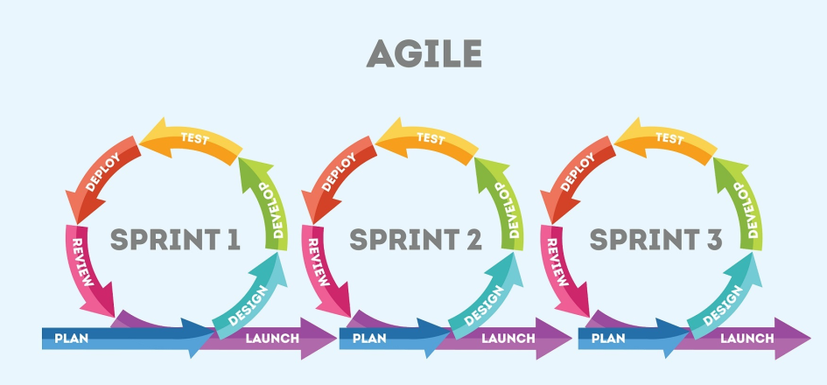

Fig: Sprints of the Agile Software Development Model

Source: (Dudhat *et al.,* 2021)

### Scrum Framework

Scrum is an approach of the agile methodology that is iterative. It helps in delivering the projects by finishing within the timeline. All these small iterations are known as sprints as I have discussed earlier the small time interval in the software life cycle. With the help of scrum, the division of workings becomes much easier thus the work finishes faster with proper quality. It is an essential step to select the sprints properly as it can affect the product. With collaboration with the other team members, the sprint has to be decided (Zayat and Senvar, 2020). As it is an iterative process in the software development life cycle, which is a long process and takes time for the developers to develop, it is broken into smaller subdivisions for proper results. There are multiple sprints such as Sprint1 Sprint2 etc. and only after meeting the outcome of the first sprint does the second one start. In this way, the Scrum framework helps in the process of software development. Also with the help of *daily scrum*, meetings can be scheduled among the team members of the project in order to discuss the progress of the work. In this daily scrum, 15 minutes of the meeting would be done to discuss further procedures of work.

### Agile in Ecogif

In Ecogif I have joined as an intern and what I have gathered is that all the employees who are designated as software developers are enough experienced and are engaged in their work with proper persistence. Thus the software products that are being developed here come out as the best of its products. This was the time when I got familiar with this methodology in particular and got to know its various benefits in software development. Delivering the product the best product is important and that is why our company Ecogif tries to focus on this method in our work. In agile the process of communication is adequate with the scrum framework, and it gets easier to communicate with the stakeholders as the work progresses or any kind of confusion gets clear there only. There are various advantages of this method such as it is prone to change, the communication is better, the collaboration between the teammates is major etc. are the reasons why our company has adopted it in order to implement the software products (Ecogif. co, 2023).

## Reasons for Choosing the Agile Method

There are various advantages of using the agile methodology in the field of software development. The main reason why the method has been selected as a Software Developer is described beneath,

***Proper Delivery***

As agile follows the Scrum framework in which there are various Sprints, the delivery of the software products never gets delayed. Sprints are generally one to four weeks and within this time the timings are done as per prioritising the project. Thus it is good to keep the adequate quality of the product so the product gets delivered to the client within its proper time. This comparatively works better than traditional software development methodologies such as the waterfall model (Karrenbauer *et al.,* 2019).

***Cost***

As in agile methodology, there are Sprints, and the time that is needed in order to complete any task is less. As less time is needed such cost gets saved in a huge amount because with lesser time the resources that are used, get utilised less also. The resources do not get wasted. Also because of Sprints, if any mistakes occur in the previous work then from the mistakes learnings can be taken which leads to better planning and leads to more savings on the cost.

***Productivity***

Because of the iterative work phases, the behaviour of the employees is trackable and in the next Sprint, we can address those mistakes. Also in this having various steps, each employee has their own particular part to play in the software development. As each one of the employees works on separate jobs, we provide our best in the job and the result turns out to be better and more productive. As we stick with one work per Sprint we are able to provide unaccountable attention which drives productivity not only in our character development but also in the product.

***Improved Quality***

In agile methodology, the quality is always assured and never compromised as all the tests are done in the Sprints. Sure to the testings in the Sprints, the code in a repetitive manner gets debugged. Also because of the iterations, the developers get to know what exactly would work properly in any particular case. This factor helps in finding the best possible solution at the proper time. Thus the quality f of the product is passed out in an improved manner (Karrenbauer *et al.,* 2019).

***Transparency***

In the agile methodology, everyone in the team has ideas about the ongoing projects and the progress of the workings. The daily reports through daily scrums and sprints were provided to the stakeholders or to the customers on a regular basis. Thus the transparency of the work in this method is smoother.

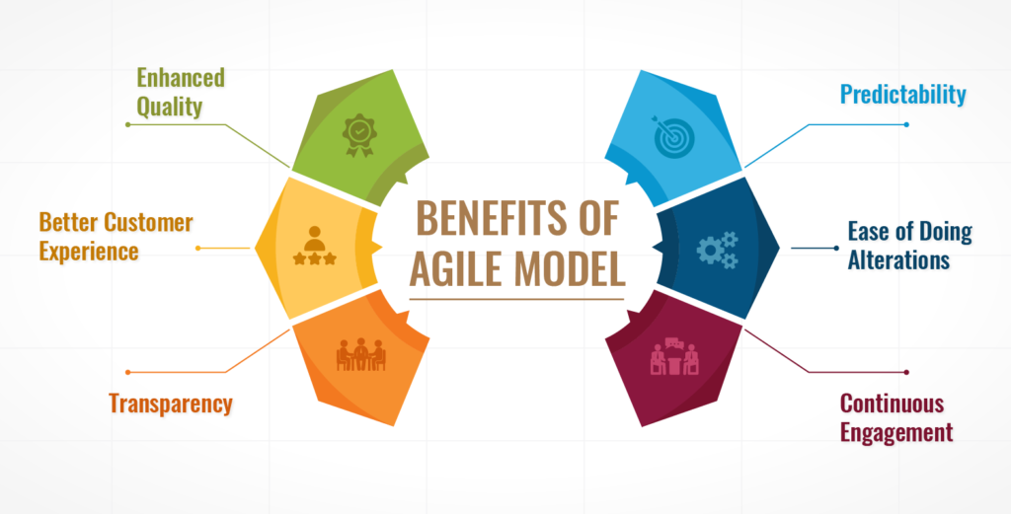

Fig: Benefits of Agile Methodology in Software Development Project

Source: (Karrenbauer *et al.,* 2019)

***Customer Satisfaction***

Agile focuses on customer satisfaction with proper importance as the highest priority. For customer satisfaction, it is important to make the products valuable and accurate as per the client's requirements. Here each sprint carries its own value as in every step the code gets debugged and if the customer does not like that that would be of no use despite how good the coding is.

***Risk Reduction***

In the case of a risk occurring at the point of development, with the help of Scrum action plans can be made as per requirements. In the case of risks, saints are done as per priorities (Karrenbauer *et al.,* 2019).

***Adaption to change***

Being an iterative method, the adopting ability to change is quicker. In each sprint, depending on the requirements changes can be made and this is why the agile methodology is flexible.

In the company Ecogif, the seniors or the team leads focus on the Agile method, for the company's success rather than following the traditional methods in order to complete the job.

## Appropriateness of the Agile Method

It has been seen in my whole time of internship various times that the appropriateness of the agile methodology in developing software has a major role to play. As there are short intervals for performing the development of the software product, it is not only dependent on the Sprints but also along with that there are various advantages of using this method such as collaboration. It is one of the reasons that the whole team can discuss the project in the agile collaborative tool. One of the best benefits of this collaboration tool is that the teammates are able to respond in the quickest way possible which leads the team to achieve the team goals. Apart from the collaboration and sprint, there are many advantages of the agile method for which it has its appropriateness. Except for Scrum, there are various frameworks of the agile method that give the method its benefits and appropriateness in software development. Kanban is one of the famous and flexible frameworks of agile methodology, Hybrid, Bimodal, XP (Xtreme Programming) etc. are some other famous frameworks that are mostly used among software developers. Each framework is used to mitigate the risks and in our company Ecogif, Scrum is used to avoid the upcoming risks in the everyday schedule and make proper planning. These are the reasons that the methodology has gained success and popularity because it is appropriate in every way possible for developing software products.

## The utilisation of programming language

As software developers, when we use the agile methodology in our development, it becomes a mixture of methodology with technology as agile is the methodology and the programming languages that are used for coding to develop the product are technology. The programming languages that I used in my internship in the Ecogif training are Python and JAVA. We software developers choose to work with the agile methodology alongside our codings to accomplish the best possible outcome in our job. In our work agile is not much of a player but combined with the programming language the best of both methodology and technology can bring out. Python is a programming language that is one of the most efficient in the case for developing any kind of software and is popular nowadays for its various libraries, frameworks, flexibility and advantages. It's been seen in many cases before that if there is any shortage in timing in the delivery of the product, then the best-qualified programming language is Python because of its libraries. In the case of a short deadline, combining with agile can make the task be done with proper accuracy. The frameworks of the Python language that go with the methodology nicely are Django, Flask, CherryPy, Bottle, FastAPI, and Web2Py ((Thaker and Shukla, 2020)). These are not only some popular but powerful framework that combined with agile makes the code more efficient. As Python is itself an efficient programming language that can make the task efficient in combination with the agile methodology the efficiency gets better. Agile along with Python delivers the best product.

As well as Python another programming language there Java which is famous among developers for building software products. It has its various advantages in itself and combining that with this methodology can only add value to the coding itself to make the product work better. Agile with JAVA development add value to the test-driven development along with its object-oriented designs and the architecture it brings into a single platform which leads to making the product go easy. This combination has the ability to make the software highly scalable and that is why our company knowing the JAVA programming language has made it easier for me to in this internship period as a software developer.

## Techniques

Techniques play a huge in agile development and that is why companies nowadays are adopting this to make their products become more reliable to the outside market and achieve success as a Software developer, I have understood why most companies are adopting this currently. It has been seen that this method is able to provide the customer with their satisfaction through the product and its service and this is one of the major things to make the product work better and improve the quality. In the agile methodology (Dudhat *et al.,* 2021), there are some techniques that every software developer should know.

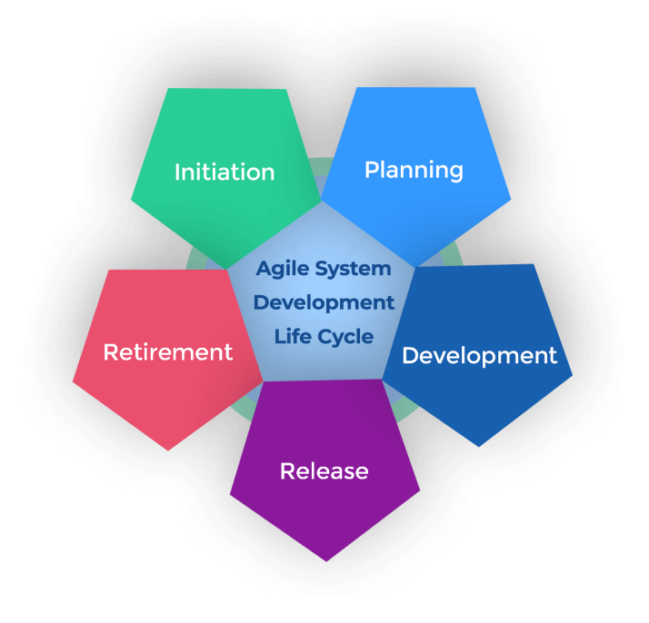

Fig: Techniques of Agile Method

Source: (Dudhat *et al.,* 2021)

The techniques include daily scrum, prioritizing the backlogs, short iterations, retrospectives and iteration planning. Following daily scrums, the meetings on a daily basis for 15 minutes would help complete the task. In addition, the next technique basically says to complete the tasks based on the priority list that has been made as per the importance of delivery time. Following that next comes the short iteration in which the task is divided for ease of doing which increases productivity within the task. Next, the retrospective is the meeting that is held for an hour after the completion of the short iterations in order to discuss the tasks and plan the upcoming tasks. Retrospectives are the key element in the way of improvement in the tasks. Finally, the last one is to plan the iteration. In a meeting, decisions are to be taken to complete the tasks with success and what goals would be achieved within the short iterations are fixed.

# Chapter 4: Analysis / Results

## Company Description

Ecogif is a privately owned manufacturing company that provides the customer with the opportunity to sell or buy goods on an open platform. The company sell the products at a very reasonable price for all types of people so that everyone can buy them also there is an option for the customer to sell their products on the platform. It is a company that is impact-centred and situated in the year 2019. The headquarters of this company is situated in Oxford, United Kingdom, Great Britain. The industry the company comes under is the manufacturing industry. The company Ecogif claims themselves as an eco-friendly organisation as the products they ake according to them they make with the help of recycled materials. Augmented reality devices are said to be made by them with the help of recycled materials. It has been observed that the company specialises in consumer goods, sustainability, consumer behaviour, local services, green products, food retail, products, smart packaging, game development, education and others (Ecogif. co, 2023).



Fig: Tag Line of Ecogif

Source: (EcoGif, Facebook)

The image above represents the logo of Ecogif Company along with their tagline that is saying "Revolutionizing Daily Spends". The company claims to be properly sustainable towards the environment. They have their campaign of going green and making the world a better place to live. As every day outside the market is getting expensive the company tries to be reasonable in making the products affordable. On their Facebook page, they run their sustainable campaign by advertising various quotes and posts. It has been that the company follows some docs on their business which is towards the betterment of our world. They try to post-awakening posts to the customer so that they can make the choice of changing their perspective of what they buy and through that buying, they actually have the power to change the world.



Fig: “Go Vegan” Campaign

Source: (EcoGif, Facebook)

Along with selling products that are environmentally friendly but also Ecogif promotes being Vegan in order to do less animal cruelty. The image has been collected from the official Facebook page Ecogif as it has been seen that they have promoted here for a better future in the world for all of us together. It is believed by the company that if any change is to happen in the world it has to be together to make that happen as "Social change is a team effort" the company has quoted (Ecogif. co, 2023).

Working in the company has led me to gather the knowledge that the company focuses on consumer behaviours as a major point. Along with that, during the internship period, I got an idea about the sustainability approach of the local e-commerce shop. As a software developer intern in this company, my job was to develop products with programming languages for the customers by following the requirements. The products that have been developed for the company can have access to those in the future times.

## Settings of the Study

As a software developer intern at Ecogif, the experience and learnings I gathered, this reflective report study has been done in order to cover those parts. In order or develop software products for the company by applying Python and JAVA programming languages I was hired there as an Intern. This internship not only benefited me in my professional life but also in my personal development. This has enriched me with professional skills that will help me in my professional career in the future timing. Along with professional and personal growth in the work the real-life experience in the professional field and about that I have encountered in this internship. In addition in the real world in the industry, how to work is undertaken at the industry level along with in-hand training on those tasks I got the experience which will indefinitely help in my career in the future. Besides all the professional and personal experience in life or professional life, the internship has helped me in learning how the behaviour and practices in a workplace should be. As this company lies in the manufacturing industry along with software development knowledge, awesome ideas about the industry are also that I have acknowledged. Again, whatever knowledge I had in my chosen field, the internship provided me with the chance to apply that knowledge in solving some real-world issues.

I am euphoric to say that my internship in the Ecogif company has helped me to learn some management work from various expertise of the company itself and I got to experience how a company runs (Ecogif. co, 2023). As per management, it has been gathered by me how projects run and how to develop any kind of project as per the client's requirements. Not only developing but the whole process of implementing the product to deliver everything I got to experience from the best of the company. Along with these, managing the budget was a part of my internship also because it was along with the agile method and managing risk so that in future the product does not have to suffer at the delivery address by me in this internship. As a start-up company, the Ecogif Company focuses on proper budgeting so that the resources do not get wasted and everything gets used correctly. This way I learned how to manage every other sector in a project and deliver that product within the provided time frame.

## Presentation of Results

In the internship at Ecogif, the responsibility I had was to develop software products and I was responsible for delivering the products by coding from the very scratch which would be dependent on the provided specifications following that the code would be tested and deployed for delivering the product with proper accuracy and fulfilling the client's requirements. In addition to this after delivering the product if any kind of complexities occur in the product then the modification along with the improvement would be done by the developer itself. In order to perform the coding from scratch in the Python programming language, there are some steps that are needed to fulfil such as making a repository in GitHub for storing the codes inside so that everything stays in one place. After following that, with proper indentation and formatting the code needs to be written for the requirements. Documentation would be needed in a proper format so that any non-coder person or people who would not have any idea about Python would understand what the coding is about. Performing the step in order to increase the efficiency in the language itself there are various libraries that can be added to the coding to make it more efficient. There are various Python libraries that are utilised for various different tasks. These Python libraries are the reason that nowadays almost every growing organisation is adopting this language in their development activities. NumPy, TensorFlow, Keras, MatplotLib, SciPy etc. are some famous Python libraries (Thaker and Shukla, 2020) that are used for different purposes in the case of developing any kind of software. Combining these libraries in the coding enhances the capability of the code which leads the code to give better results at the end of the time of delivering the project.

Besides Python, in the internship, I even used JAVA language in order to build software products for the Ecogif Company. As a Java developer, I have used the steps of developing any product in a proper way. Java is a programming language that is used widely and most special fiscally it is used by huge organisations but Ecogif being a startup does. Not use Java for their developmental purposes on a daily basis. However, as an intern, as I had prior knowledge of Java, they gave me projects whose requirements were based on Java. While working I have gathered that Java is better in the case of using it in Android. It has been seen in my previous project that with Java the program gets better speed thus it is an efficient coding language for use in developmental cases. Also, it is a typed language thus it brings better scalability and security to the applications. Along with me, there were some other software developer interns present at the time at the company and all of us were divided among smaller IT teams. These smaller IT teams were made because of the Agile methodology environment to perform the jobs in a more productive and efficient manner.

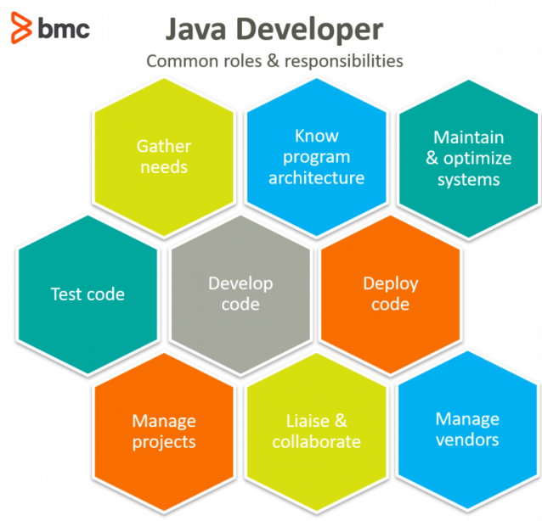

Fig: Responsibilities of Java Developer

Source: (Khoirom *et al.,* 2020)

In the image above the roles and responsibilities have been illustrated. As a software developer, there are two parts one is the front end and the other one backend. Through Java, both parts can be performed. There are some skills that are needed to learn before doing any coding with Java such are, HTML, XML, JSON, CSS, JavaScript, JSP, and Servlet. Along with these, their knowledge of the database is also needed as the database needs to be connected to the application. Thus knowing the concept of both SQL and NoSQL is essential such are MySQL and MongoDB. Nowadays no developer performs the coding in the command prompt anymore as in the market Java IDE like Eclipse or IntelliJ has won the market with their user-friendly interface. Thus having knowledge about these IDEs is important too. Applying Java frameworks to the codings increases the efficiency of the product. Frameworks such as Spring, JSF etc. All these activities combined have made me result good in the internship at Eccogif company to prove myself and make my professional career better by enhancing my personal growth.

## Findings

At the company Ecogif the role of agile methodology in the field of Software Development was evaluated by me in a critical manner through the project that I have done here in this internship. In this internship depending on the requirements, I have applied both Java and Python for making the front end and back end of the software product. Here my primary goal was to create software that would be profound and whose functionalities are proper and user-friendly. Regarding this, there are a few techniques that I have learned and applied those would be having the capability to make my work gathered by me in the internship time period at Ecogif. Apart from my core department which is software development, I learned so many things that are important in an organisation which as effective communication. In the agile method, daily scrum meetings would be done so that feedback can be gathered on a daily basis so that the quality of tasks improves. Also, trough having effective communication and proper collaboration among the team members encourages the team members to be more productive which leads the tasks to be better and would able to mitigate upcoming risks. In the meantime by learning and improving all the other factors I have worked on my decision-making and real-world problem-solving activities so that they would help me in the future.

# Chapter 5: Interpretation and Conclusion

In this internship report, in order to perform the internship in software development the agile methodology has been selected. Within the discussing sector of agile software development methodology separating priorities as per requirements and completing the task without any complexion has been the main focus.

## Points from the Literature

The diverse parameters in the development domain and how to achieve the measurements have been the fundamental interpretation of this study. All the projects that I have done in the organisation have been done keeping in mind the requirements that have been provided by the client and making a list of these requirements. The company Ecogif has provided me as a software developer intern with the responsibility of developing software applications that would be full-fledged with accurate functionalities. Apart from developing full-fledged software applications, I modified some software that was present in the company. As an intern at the company the seniors or the people having expertise in the domain have guided me through their expertise in work to make my work better and more efficient.

Together with the help of my team members and seniors, I learned in my internship period about the daily scrub meetings and I also learned how to implement one of those. Working as a software developer intern in the company knowing Python programming language and Java programming languages came in convenient. In the company, Ecogif, the role that was assigned to me had been related to developing software applications where modifications in the existing software products were related to my job specification. Both programming languages have helped me to a great extent in order to complete my internship. The reason why I choose this line of work is that in this line I get to help people in their everyday life by building the applications which they use on a regular basis. In the literature section, various aspects have been illustrated of how software development works.

Together with the programming languages Agile and Scrum have helped me appropriately manage my tasks and motivated me to keep going and be engaged with projects. At times of having issues with requirements from the clients, agile being a customer-centric approach has guided me in getting better results in my tasks.

## Practical Application

In the field of software development technical expertise is required in practical applications. In my internship tenure at the Ecogif Company, I was appointed as a software developer intern where my practical knowledge was highly required. In the activity, it can be said that the norms along with the company culture that they have, affected my process of developing software even in the deployment or management of my tasks. This internship period has offered me growth in my professional career along with my personal skill development which will be valuable in my real-life experience in the future. The background in the digitisation that has occurred in recent times has aided me in order to acclimating the technological techniques to acceptability where the logical implementation of development aspects is sufficiently demonstrated in the ever-changing scenery of customer demands. The constant iterative upgrades in the agile methodology and in scrum have led me to the acceptance of adaptability and merged in this one internship report focusing on the advantageous parts. During this whole internship, I gathered that scram was one of the most important aspects of the agile process and in order to make the tasks proper and accurate as per requirements the daily scrum is how much important for our company. The agile process has helped me in achieving the goal that I set at the beginning time of entering this internship. Even though I had knowledge of the Python and Java programming languages while developing the tasks, many new algorithms and coding techniques I learned would be convenient for my future work in different aspects. During this time period, I was able to learn new things not only in the technical part but also in the managerial part so that when I am working in the industry I can manage my work as per the requirements.

## Conclusion

From the Internship report that I have been writing here, I can conclude that being hired as an intern at the manufacturing company Ecogif, the designation of software developer intern has not only made my professional skills far better, but also has polished my personal skills. The use of various programming languages has added value to my professional life in regard to performing the software developer role. The outside market is getting pricey every day for some people it is getting tough in order to afford daily life things but this company have made me realise that in order to do business it is not always necessary to set the prices upwards. Apart from all the technical learning I have learnt this basic thing about life: as human beings, we should be sustainable towards our mother Nature. At the beginning of the internship report paper, an introduction about my internship and why I have chosen this role and this internship along with some objectives of choosing the internship has been discussed. Following that the objectives have been addressed by reviewing and in addition to what method have been chosen in order to do the software development process and to make this internship report has been discussed in brief. Following the methodology that has been chosen for this internship results that have been obtained by this internship have been illustrated after that the interpretation from the reviewing of the objectives has been discussed. The company has hired me in order to provide the best real-life work experience that I could get for the betterment of my career. During this internship, I have learnt that in the role of software development, there is not only the part where as a developer we write code but there are so many parts where various factors are to be considered before developing one software product. For developing any software application there are some steps that need to be followed by every developer. As the agile methodology and daily scrum meetings are necessary processes of everyday routine, I understood that the software development life cycle is an essential process in order to deliver the software application product in the best way possible depending on the requirements of the client. As an intern in the company as a software developer my responsibilities were to build proper and accurate functionality software applications for the customers with the help of programming languages that I knew were Python and Java. Both of these languages are used as a part of the front and back end in order to make software applications depending on the requirements. At the critical points in this internship, I developed my critical thinking ability and decision-making ability in a stronger way. Also, the daily scrum meetings have made me realise how much collaboration is for work to be effective and productive. In the end, it can be said that this internship has a major role in my career and it made me better in so many ways that would help me in achieving my dreams in the future.

# Reference List

de Vicente Mohino, J., Bermejo Higuera, J., Bermejo Higuera, J.R. and Sicilia Montalvo, J.A., 2019. The application of a new secure software development life cycle (S-SDLC) with agile methodologies. Electronics, 8(11), p.1218.

Dudhat, A. and Abbasi, M.A., 2021. Discussion of Agile Software Development Methodology and its Relevance to Software Engineering. ADI Journal on Recent Innovation, 3(1), pp.105-114.

EcoGif (no date) Facebook. Available at: https://www.facebook.com/ecogif/ (Accessed: February 25, 2023).

Ecogif | linkedin (no date). Available at: https://www.linkedin.com/company/ecogif (Accessed: February 25, 2023).

Ecogif.co. 2023. EcoGif App. [online] Available at: <https://ecogif.co/> (Accessed: February 25, 2023).

Karrenbauer, J., Wiesche, M. and Krcmar, H., 2019. Understanding the benefits of agile software development in regulated environments.

Khoirom, S., Sonia, M., Laikhuram, B., Laishram, J. and Singh, T.D., 2020. Comparative analysis of Python and Java for beginners. Int. Res. J. Eng. Technol, 7(8), pp.4384-4407.

Kumar, R., Maheshwary, P. and Malche, T., 2019. Inside agile family software development methodologies. International Journal of Computer Sciences and Engineering, 7(6), pp.650-660.

Perkusich, M., e Silva, L.C., Costa, A., Ramos, F., Saraiva, R., Freire, A., Dilorenzo, E., Dantas, E., Santos, D., Gorgônio, K. and Almeida, H., 2020. Intelligent software engineering in the context of agile software development: A systematic literature review. Information and Software Technology, 119, p.106241.

Saeed, S., Jhanjhi, N.Z., Naqvi, M. and Humayun, M., 2019. Analysis of software development methodologies. International Journal of Computing and Digital Systems, 8(5), pp.446-460.

Thaker, N. and Shukla, A., 2020. Python as multi paradigm programming language. International Journal of Computer Applications, 177(31), pp.38-42.

Zayat, W. and Senvar, O., 2020. Framework study for agile software development via scrum and Kanban. International journal of innovation and technology management, 17(04), p.2030002.